Wilson Family Seeds

Home Grown Fun™

BUCK’S SEED

**ORGANIC SEED**

Gourd Sampler

Bow Wow Beans

**Bush Type. Heirloom because they’re old.**

**Bow Wow Beans and Rice are a favorite family dish around here.**

**We promise when you eat them you won’t produce as much gas as Buck!**

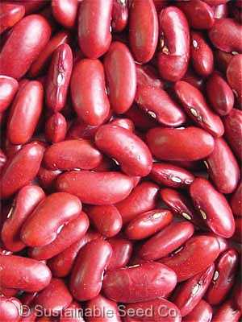

**Plant 1.5 inches deep, 4-6” apart. Takes 7-10 days to germinate. Mature in 50-60 days for green, 100+ days for dry beans. Must have temps 65° or higher. Grows best in full sun with well watered soil. Harvest young pods often to get more.**

***Buck says,***

***Eat Beans to Keep Your Body Leans***

FUN Snake, Bottle and Loofah Gourd Seeds!

homegrownfunfamily@gmail.com

Home Grown Fun™

*(Scientific Name - optional)*

**Replace this description with yours…Example: Dark-green, glossy, spoon-shaped leaves have anti-bacterial properties.**

Year Seed Harvested:

**Plant outside when nighttime temps**

**are above 50 degrees - inside anytime.**

**Cover with 1/8”-1/4” of fine soil and**

**keep moist. Germinates in 6-15 days.**

**Height 24-30”. Matures in 68 days.**

**Home Grown Fun**™ **SEED ENVELOPE TEMPLATE** *CONDITIONS OF USE: Do not distribute or sell the template or design to others.*

**INSTRUCTIONS & TIPS:** 1) Save the file with a new name. 2) Change the text to customize. Do not let the text description on the back of the envelope extend beyond the text box. (Flaps from the front will overlap the back.) 3) To change the image, click on the image and go to the menu Drawing Tools>Format>Shape Fill>Picture. Choose an image from your computer. 4) Print one sheet and cut along dotted lines. 5) Fold the spine first at the edge of the image and then fold all flaps toward the back of the envelope. 5) Use a permanent glue stick to apply an even amount of glue to all flaps except the top. Glue sides and bottom securely. 6) Once seeds are added, keep the seeds at the bottom while you glue the top.